**IHomework 1**

**Please submit this document to iCollege by 2021/1/17 11:00pm. Late submission will not be accepted.**

1. What are the benefits of using Git in a project? (5 points)

Git is one of the most popular “version control” systems around, it keeps track of multiple edits (versions) of files and versions. It gives you a time machine for going back to earlier versions. Changes are also merged during concurrent work. It is cheap to create new branches and merge. All your files’ appearance is recorded at given times.

1. Explain the concepts of (a) working tree, (b) staging area (c) git repository. (15 points)
2. It consists of the files that you are currently working on. Just like a file system where you can view and configure certain files. You can add new files and remove useless files from here.
3. A staging area is a middle layer where files that are added are being made ready to be committed. This is an area where you come up with (conjure) commits to the final repository. It is just like a gift-box where you can put and take things out. Committing is like sealing the gift-box and gift-wrapping it.
4. This is the .git/ folder inside a given project. This helps you build a history of the project over time, as it tracks every change you make to the files inside it. Once you commit and push changes, all the files and versions will be stored in the repository.

**For following questions, please show your work with screenshots. (80 points)**

1. Sign up a github account, create a public github repo named “HW1”, and then use **git remote** to set up your local repo. You may refer to the hints shown on the github page.

Copy and paste your github repo link here.

<https://github.com/preethampython101/HW1>

1. Create a python file named “sum.py” in the folder you pulled in previous step. Open it with an editor and write a python program which calculates the sum of 1 to 100.

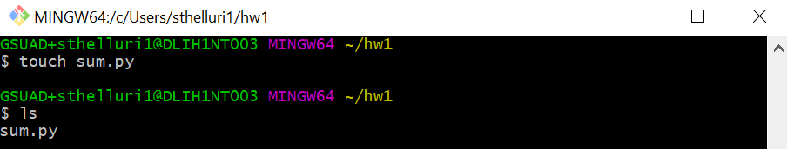

1. Use **git add** to stage the file “sum.py”.

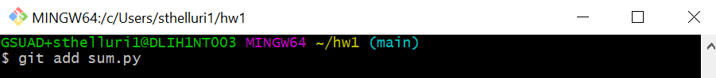

1. Show **git status.**

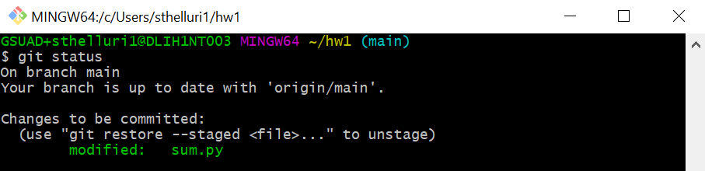

1. Do a **commit**. Make a meaningful comment when you commit.

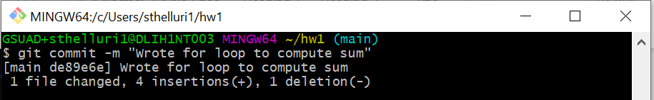

1. Show **git status** again.

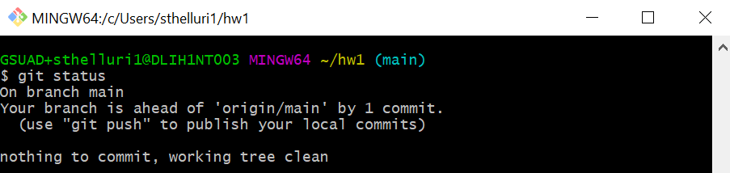

1. Edit “sum.py”. Insert one comment line (start with “#”) at the top to describe the function of your code.



1. Stage the file and commit it again. Make a meaningful comment when you commit.

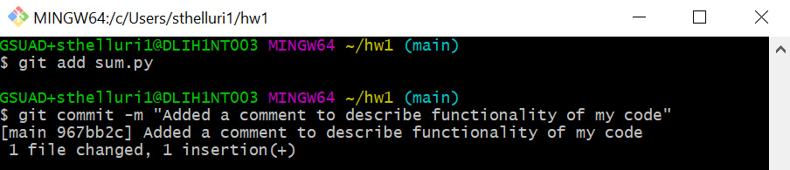

1. Push your commits to github.

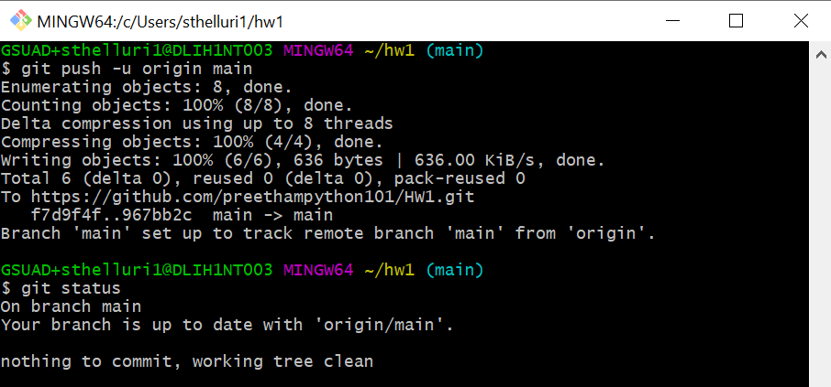

1. In which folder does git store your repo? List all files inside this folder.

My repo is stored in the “.git” folder. 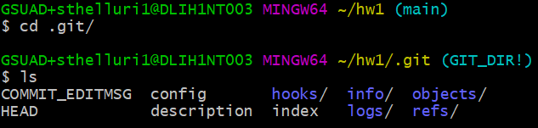

I have listed the files here.

Note:

See how to show hidden directories or files in Widows. <https://support.microsoft.com/en-us/windows/show-hidden-files-0320fe58-0117-fd59-6851-9b7f9840fdb2>

See how to show hidden directories or files on a Mac. <https://www.macworld.co.uk/how-to/show-hidden-files-mac-3520878/>